Task No 01: Design a webpage including html & CSS. Include all the things told in lab and the things included in assignment. The following navigation tabs must be added:

1. Home (Give info about what your website is about).
2. Information (Include the detailed information related to the technology).
3. Gallery (Include images and Videos of technology).
4. About (Give the information about yourself).

Home:

Input:

<html>

<head>

    <link rel="stylesheet" href="style.css">

<body>

<ul>

<li> <a class="active" href="E:\Notes\1st Semester\Computing Fundamentals\Computing Fundamentals Lab ( CSL-110)\Lab 8\Tasks Part By part\Home.html">Home</a></li>

<li><a href="About.html">About</a></li>

<li><a href="Gallery.html">Gallery</a></li>

<li><a href="Information.html">Information</a></li>

</ul>

<center>

    <h2>Hi! Welcome to "AS Captures"</h2>

    <h4>An Art Gallery where you will find some pieces of nature</h4>

</center>

</body>

</head>

</html>

Output:

About:

Input:

<html>

<head>

    <link rel="stylesheet" href="style.css">

<body style="background-color:hsl(0, 0%, 100%);" padding="10"">

    <center>

        <h2 style="color: white; background-color: rgba(139, 35, 187, 0.842);">About</h2>

        AS Captures is an Art gallery managed by Abdullah Sadiq, a boy passionate toward capturing Nature. You will find pictures related to nature on this Art gallery. You can explore nature by Watching Heart Warming Scenes captured By him. The motive is to present beauty of Nature and give a different vision of Nature.

    </center>

</body>

</head>

</html>

Output:

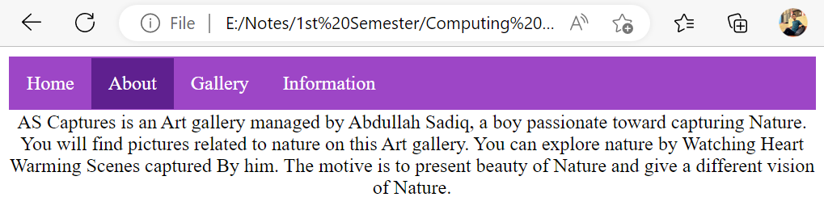

Gallery:

Input:

<html>

<head>

    <link rel="stylesheet" href="style.css">

<body>

    <ul>

        <li> <a class="active" href="E:\Notes\1st Semester\Computing Fundamentals\Computing Fundamentals Lab ( CSL-110)\Lab 8\Tasks Part By part\Home.html">Home</a></li>

        <li><a href="About.html">About</a></li>

        <li><a href="Gallery.html">Gallery</a></li>

        <li><a href="Information.html">Information</a></li>

        </ul>

<center>

    <p> Here are some of the pictures Clicked by Abdllah Sadiq. </p>

    <img src="E:\Photoshop\Sunset.jpg" alt= height = "82" width = "82">

    <img src="E:\Photoshop\bahria1.jpeg" alt= height = "82" width = "82">

    <img src="E:\Photoshop\bahria2.jpg" alt= height = "82" width = "82">

    <img src="E:\Photoshop\dow1.jpg" alt= height = "82" width = "82">

</center>

</body>

</head>

</html>

Output:

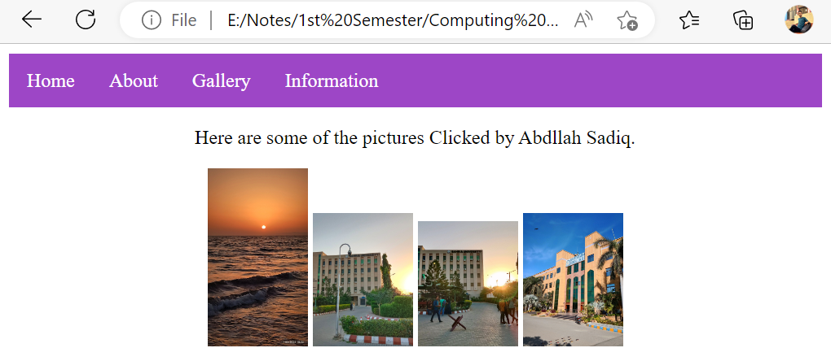

Information:

Input:

<html>

<head>

    <link rel="stylesheet" href="style.css">

<body>

    <ul>

        <li> <a class="active" href="E:\Notes\1st Semester\Computing Fundamentals\Computing Fundamentals Lab ( CSL-110)\Lab 8\Tasks Part By part\Home.html">Home</a></li>

        <li><a href="About.html">About</a></li>

        <li><a href="Gallery.html">Gallery</a></li>

        <li><a href="Information.html">Information</a></li>

    </ul>

    <center>

        <P>AS Captures is an Art gallery managed by Abdullah Sadiq, a boy passionate toward capturing Nature. You will find pictures related to nature on this Art gallery. You can explore nature by Watching Heart Warming Scenes captured By him. The motive is to present beauty of Nature and give a different vision of Nature.

        </P>

        <H5>To Get Access to our Art Gallery, Follow us on Social Media

        Here are some of Social media Platforms: </H5>

        <a href="https://www.facebook.com/AS.Capturess?mibextid=ZbWKwL">Facebook</a>

        <a href="https://instagram.com/as.captures._?igshid=Yzg5MTU1MDY=">Instagram</a>

    </center>

</body>

</head>

</html>

Output:

